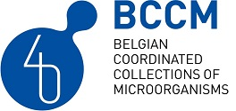
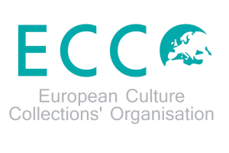
ECCO XLI – 2023

Preliminary program

Tuesday 19 September
9:30: MALDI-TOF training
13:00: Welcome + ECCO registration
14:00: Keynote lectures
16:00: Opening Expo 40 years BCCM + networking reception
18:00: Walking buffet + animation

Wednesday 20 September
8:30: ECCO registration
9:00: Welcome address
9:15: Session 1 - Microbes in Health & Disease
Chair: Rudi Beyaert + ECCO board member
Keynote speaker: Chris Callewaert (UGent, Belgium): The science of body odor
Keynote speaker: Lars Vereecke (VIB, Belgium): Studying the microbiota-immune-tumor axis in colorectal cancer using germfree and gnotobiotic mouse technology
Nicolas Bruffaerts (Sciensano, Belgium): Airborne fungal spores in the outdoor air
10:30: Break
11:00: Session 2 - Microbes in Health & Disease
Speakers to be confirmed
12:30: Lunch
13:15: Session 3 - Microbes in Food and Agriculture
Chair: Stéphane Declerck + ECCO board member
Speakers to be confirmed
14:45: Break
15:15: Session 4 - Microbes in Food and Agriculture
Speakers to be confirmed
16:30: End of session
17:30: Guided visit Chocolate museum

Thursday 21 September
9:00: Session 5 - Microorganisms in ecological applications
Chair: Annick Wilmotte + ECCO board member
Keynote speaker : Beatriz Roncero Ramos (University of Seville, Spain): Survival mechanisms of Antarctic microorganisms
10:30: Break
11:00: Session 6 - Microorganisms in ecological applications
Speakers to be confirmed
12:30: Lunch
13:15: Session 7 - Taxonomy, Phylogeny, Phylogenomics, Phylodynamics: new techniques and approaches
Chair: Leen Rigouts and Peter Vandamme
Keynote speaker: Connor Meehan (Nottingham University, UK): Phylodynamics in mycobacteria
Luc Cornet (UCL, Belgium): the BCCM GEN-ERA project
Frederik Baert (Sciensano, Belgium): Comparing culture collection strains
14:45: Break
15:15: Session 8 - Data management, infrastructures
Chair: BCCM coordination cell member + ECCO board member
Speakers to be confirmed
16:30: End of session
19:00: Conference dinner Atomium

Friday 22 September
9:00: Session 9 – Science policy, career skills, valorization of collections
Chair: BCCM coordination cell member + ECCO board member
Speakers to be confirmed
10:30: Break
11:00: ECCO AGM
13:00: Closing lunch

